# Semester Project, SE 5101, Fall 2019

Currently earthquakes, and their potentially devastating effects, are only detected after they have occurred. The distance from the epicenter that a populated area is determines how much warning they could receive to prepare for the earthquakes’ effects if they are notified immediately. Earthquakes are primarily a result of sudden violent shifts between two or more adjoining plates in the earth’s crust. The greater the shift, the higher magnitude the earthquake. All of the plates comprising the crust are in constant movement; thousands of earthquakes occur every day; but most are of a small enough magnitude that no damage occurs. For example, the pacific plate movement affects 7 adjoining plates (see figure below). Although the overall movement of the plate is continuous with one plate sliding by the adjoining plate(s), there are points along the interface where essentially the plates get stuck. As a result, stress builds up at those points (to the extent that rocks are elastic) where the plates are stuck until sufficient force is applied by the movement of the plate to break it loose at the stress point. The sudden and potentially violent movement associated with releasing that stress is an earthquake.

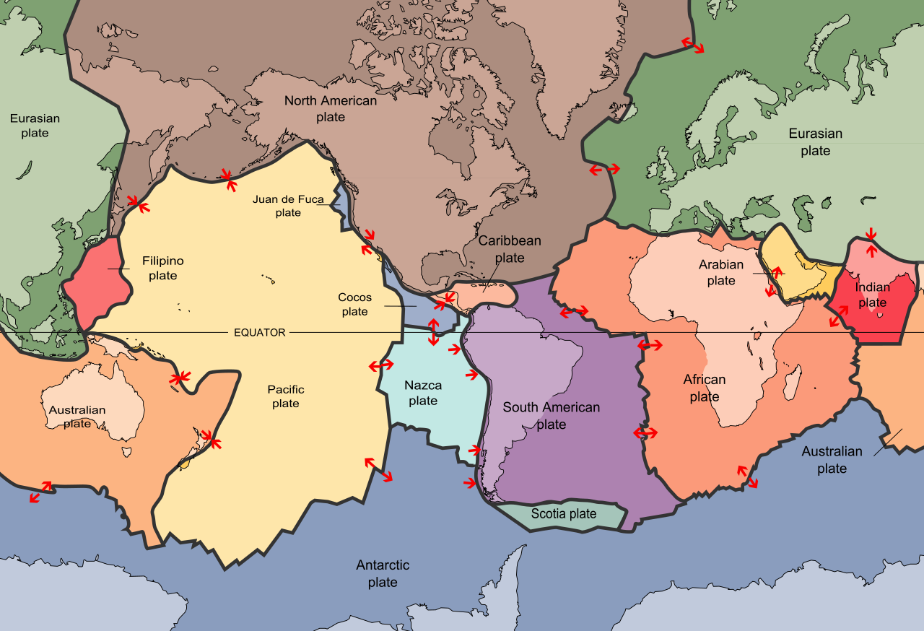

Assume some seismologists believe they have discovered what they think is a way to predict a quake’s location and magnitude several hours in the future for several densely populated, seismically active areas of interest.

A prototype **system** is needed to demonstrate a functional approach to identify where stress is building up between adjoining plates, quantify the stress, and predict the magnitude of the earthquake when a section of the plate will move, based on the estimated stress and breaking point.

The first phase of the project is to gather data on a representative plate and identify sticking points between the target plate and the adjoining plates to understand the plate movement; where it is moving and where the movement is restricted. Based on the differential in movement, referred to as movement differential, and elasticity of local crust, the stress can be inferred. The greater movement differential, the greater the stress between those two plates at a specific point versus the adjoining points at the interface where there is movement. The movement differential will continue to increase until the plate breaks free at the sticking point and moves, relieving the stress at that point. The depth of the quake is also important to the amount of shaking felt at the surface.

The next phase of the project is to correlate the movement differential value at the time when the plate breaks free to seismic data collected before the event. The prototype should learn and develop a predictive model that correlates movement differentials of surrounding areas (i.e., precursor signals) to impending earthquake magnitude. The prototype should also use the correlated data to identify the probability of sudden movement, an earthquake, based on the movement differential.

The third and final stage of the project is to use the predictive model to forecast probability of when and where an earthquake associated with the target plate will occur and the magnitude of the quake.

Some Questions to think about (I don’t want these directly answered, but they’ll factor in to the project deliverables and the 4 homework assignments):

* What does your proposed system actually do? What **functions** (of *your* system, as well as associated systems *outside* your system) take place as it operates?
* Who are the stakeholders? And/or customer(s)?
* What is your ‘value proposition’ – how much would it help to have advance notice of a quake? By how long? Who will be aided by this knowledge?
* What is the actual **need** **statement** for such a system? (this is your group **Assignment 0** – turn in the **Need Statement** for your system (of systems, perhaps)) – one page or less the second week of class
* What systems already exist to provide data you need; that is, do existing sensor networks exist, and do they provide the right data, as well as enough data, to make your system work? What are the interfaces, how will you define the interfaces, and how will you obtain the data you need from them?
* Who pays for your staff, offices, capital equipment, computer time, internet connections, etc. during development? During operation?
* What if you predict one, and you’re **wrong**? What if you **don’t** predict one, and you’re wrong!
* Who does your project report to directly?
* How big an organization do you need?
* How do you specify and monitor input data quality? Output data? Synchronization?
* What’s the threshold magnitude prediction that you report? To **whom**? Who gets the notice? How far ahead? What are your error bounds for the prediction?
* What is the openness policy on the prediction data? Is there anyone you wouldn’t give it to?
* Is the prediction a daily/hourly/etc. **batch** process or **continuous** process?
* How large an area does your project cover for its prediction? Be reasonable

Some background and source material about earthquakes in these links, that located within 300 seconds by me (do better!) (someone on your team should check them all): No need to do this for the United States; anywhere you like.

<https://www.forbes.com/sites/robinandrews/2019/07/23/watch-30-years-of-earthquakes-rock-california-in-this-remarkable-animation/amp/> **(second picture is the movie – watch several times!**)

https://www.newsweek.com/los-angeles-earthquake-app-tells-residents-brace-quake-will-be-revealed-1277765

<https://www.iris.edu/hq/programs/gsn> <https://pnsn.org/tremor>

<https://link.springer.com/chapter/10.1007/978-3-319-21314-9_8>

<http://worldweather.wmo.int/en/home.html>

<https://www.25af.af.mil/About-Us/Fact-Sheets/Display/article/333995/air-force-technical-applications-center/>

<https://www.scientificamerican.com/article/searching-for-signs-of-the-next-catastrophic-quake/>

<https://www.deepdyve.com/lp/springer-journals/evolution-of-mechanical-properties-of-granite-at-high-temperature-and-bcYdcqx1oh>

<https://www.scientificamerican.com/article/early-warnings-of-terrible-earthquakes-appear-high-in-the-sky-a-new-theory-says/>

<https://progearthplanetsci.springeropen.com/articles/10.1186/s40645-018-0221-6>

[http://www.latimes.com/local/lanow/ la-me-ln-earthquake-early-warning-20180322-htmlstory.html](http://www.latimes.com/local/lanow/%09la-me-ln-earthquake-early-warning-20180322-htmlstory.html)

<https://www.nationalgeographic.com/science/2019/07/tectonic-plate-dying-oregon-why-matters/>

<https://www.turnto23.com/news/local-news/aftershocks-around-ridgecrest-appear-to-be-headed-for-garlock-fault-could-cause-magnitude-8-quake>

<https://www.sfgate.com/bayarea/article/Earthquake-swarm-hits-California-with-1-000-14017449.php>

<https://markets.businessinsider.com/news/stocks/california-earthquake-drought-big-quake-any-time-2019-5-1028212309>

<https://www.king5.com/article/weather/earthquakes/tremor-bursts-south-of-seattle-continue/281-0c9be3cd-6b81-406d-96bd-e6328ad3684d>

<https://www.nationalgeographic.com/science/2019/05/tectonic-plate-peeled-apart-could-shrink-atlantic-ocean-geology/>

<https://phys.org/news/2019-05-earthquakes-triggered-fluid-zones.html>

[https://earthquake.usgs.gov/earthquakes/map/#%7B%22autoUpdate%22%3A%5B%22autoUpdate%22%5D%2C%22basemap%22%3A%22grayscale%22%2C%22feed%22%3A%2230day_m25%22%2C%22listFormat%22%3A%22default%22%2C%22mapposition%22%3A%5B%5B-80.53207112232732%2C-40.78125%5D%2C%5B80.47406532116933%2C440.859375%5D%5D%2C%22overlays%22%3A%5B%22plates%22%5D%2C%22restrictListToMap%22%3A%5B%22restrictListToMap%22%5D%2C%22search%22%3Anull%2C%22sort%22%3A%22newest%22%2C%22timezone%22%3A%22utc%22%2C%22viewModes%22%3A%5B%22settings%22%2C%22map%22%5D%2C%22event%22%3Anull%7D](https://earthquake.usgs.gov/earthquakes/map/#%7B%22autoUpdate%22%3A%5B%22autoUpdate%22%5D%2C%22basemap%22%3A%22grayscale%22%2C%22feed%22%3A%2230day_m25%22%2C%22listFormat%22%3A%22default%22%2C%22mapposition%22%3A%5B%5B-80.53207112232732%2C-40.78125%5D%2C%5B80.47406532116933%2C440.859375%5D%5D%2C%22o)

courtesy xkcd, <https://xkcd.com/2058/>

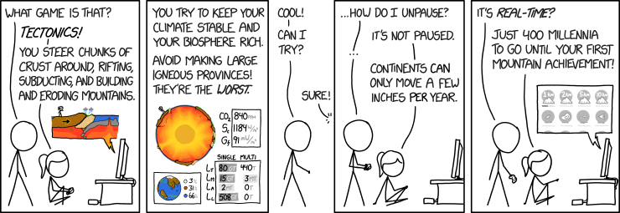

Courtesy xkcd, <https://xkcd.com/2061/>